# BM-EPBL/IBM-Project-27133-1660047356

**ARUN.M (19205003)**

**KARTHIK.M(19205018)**

**NAVEEN.E (19205030)**

**RESHMA.S (19205039)**

**in partial fulfillment for the award of the degree of**

**BACHELOR OF TECHNOLOGY**

**SMART FARMING ENABLE AGRICULTURE USING IOT**

**Abstract:**

Climate changes and rainfall has been erratic over the past decade. Due to this in recent era, climate-smart methods called as smart agriculture is adopted by many Indian farmers. Smart agriculture is an automated and directed information technology implemented with the IOT (Internet of Things). IOT is developing rapidly and widely applied in all wireless environments. In this paper, sensor technology and wireless networks integration of IOT technology has been studied and reviewed based on the actual situation of agricultural system. A combined approach with internet and wireless communications, Remote Monitoring System (RMS) is proposed. Major objective is to collect real time data of agriculture production environment that provides easy access for agricultural facilities such as alerts through Short Massaging Service (SMS) and advices on weather pattern, crops etc.

**I.Introduction**

This theory stems from advancements including the Internet of Things, Big Data, and Cloud Computing, among others, which have given rise to the concept of smartness. Farming IoT is a network of monitors, cameras, and computers that can all function together to help a farmer perform his job more effectively. This computer would be self-sufficient so that they will be able to interact with one another without the need for human intervention. To put it another way, the gadgets are pre-programmed with the knowledge of the moment and the motives for communicating with other instruments

in the scheme. Several agricultural industries have switched to IoT engineering for smart farming to increase productivity, performance, global market, and other features such as minimal human interference, time, and cost, among others. The advancement in technology ensures that sensors are becoming smaller, more modern, and more affordable.

**METHODOLOGY:**

.

**Internet of Things (IoT)**

The Internet of Things (IoT) is the most productive and essential methodology for designing solutions to problems. IoT grows from a number of building blocks, such as sensors, applications, network elements, and other electronic devices. improves the effectiveness of knowledge. IoT allows data to be exchanged across a network without the need for human intervention. In the Internet of Things, be prepared to converse with objects in a natural fashion, rather than in the manner of a regular human being, such as a sensor, a car driver, and so on. This object has been given an address so that it can transmit data across a network.

**Smart Agriculture Using IoT**

Agriculture is India's economic development's most important pillar. Climate change is the most important boundary that conventional farming faces. Overwhelming flooding, the most extreme hurricanes and warm winds reduced rainfall, and other climatic shifts are among the many consequences. As a consequence of these considerations,

performance suffers greatly. Climate change often has natural effects, such as periodic shifts in plant lifecycles. In order to increase productivity and reduce boundaries in the farming sector, creative creativity and Internet of Things strategies were needed. The Internet of Things (IoT) is now shifting its focus to the agricultural sector, enabling farmers to face the immense

obstacles they face. Using IoT, farmers may gain access to a wealth of data and knowledge regarding future trends and innovation.Since global agriculture is becoming more industrialized, it is critical to establish

agricultural interdepartmental cooperation at the same time.

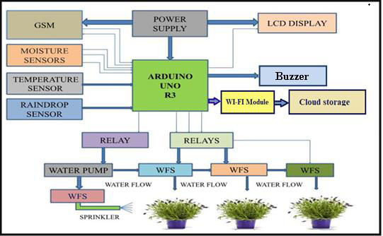 Agricultural intercolumniation has resulted in a positive change in global agriculture. As far as agricultural improvement is concerned, rural intercolumniation can be a major impediment to agricultural progress and reform and a cornerstone for sustaining stable and sustainable economic growth. We've been concentrating on agricultural data gain and framework improvement for a while now. Exceptional results had been shown in rural system improvement after several years of challenging efforts [2]. Smart agriculture is a broad term that refers to agricultural and food production practises that make use of IoT, big data, and advanced analytics. The Internet of Things refers to the integration of sensing, automation, and analytics technology into present agricultural processes.

The several factors which affect the amount of water required by crops in various climatic conditions are:

1. Temperature

2. Humidity

3. Sunshine

4. Wind speed

**Extremely efficient:**

A. IoT-enabled agriculture allows farmers to monitor their products and conditions in real time. They By the time we reach 9 billion people, 70% of the world's population will be living in have fast perceptions, can predict issues before they arise, and make well-informed decisions on how to avoid them. Agriculture IoT solutions include automated features such as demand-based watering, fertilisation, and robot harvesting.

**Expansion :**

IoT-based greenhouses and hydroponic systems, which should be able to feed these folks with fresh fruits and vegetables, enable short food supply chains. Thanks to sophisticated closed-cycle agricultural systems, food may be produced in supermarkets, on the walls and rooftops of buildings, in shipping containers, and, of course, in the comfort of everyone's home.

**Resources are in short supply**:

Many agricultural IoT solutions seek to make the most efficient use of resources like water, power, and land. Precision farming is based on data acquired from a variety of sensors in the field, allowing farmers to precisely allocate exactly adequate nutrients to one plant.

**Hygienic Procedure :**

Smart farming using IoT is a tried-and-true method of reducing pesticide and fertiliser consumption. Precision farming not only saves water and energy and makes farming more ecologically friendly, but it also drastically decreases the need of pesticides and fertilisers. In compared to traditional agricultural methods, this technique yields a cleaner, more organic end product

**Agility:**

One of the benefits of using IoT in agriculture is the increased adaptability of operations. Thanks to real-time monitoring and forecasting technologies, farmers can react quickly to any significant change in weather, humidity, air quality, or the condition of any crop or soil in the field. Agriculture specialists can now save crops in the face of extreme weather changes thanks to new skills

**Major Applications**

Each aspect of conventional farming strategy can be modified on a very simple level by implementing the most recent detecting and IoT advances in agriculture practices. Right now, consistent convergence of wireless sensors and the Internet of Things in smart agriculture will propel agriculture to previously unimaginable heights[4]. IoT may help advance the solutions to various typical farming problems, such as dry spell

reaction, surrender optimization, arrive reasonablenIBM-27133-1662613729ss, water method, and bother regulation, by adopting the tenets of savvy agriculture.

**Data Analytics:**

IoT device data necessitates more storage than a conventional database system can supply. Cloud-based data storage and an end-to-end IoT platform are critical components of the smart agriculture system. These systems are

expected to play a key role in facilitating the execution of better tasks. In the IoT era, sensors are the primary source of large-scale data collecting. The data is analysed and transformed into valuable information using analytics tools. Data analytics may be used to analyse weather, livestock, and agricultural conditions. Using technological improvements, the knowledge obtained enables for better decision-making. You may learn about the real-time status of your crops by collecting data from sensors utilising

IoT devices. Predictive analytics can help you gain insight into harvesting decisions and make better ones. Farmers can utilise trend analysis to forecast upcoming weather and crop harvesting circumstances. IoT has assisted farmers in preserving crop quality and soil fertility, resulting in increased production volume and quality in the agriculture

business.

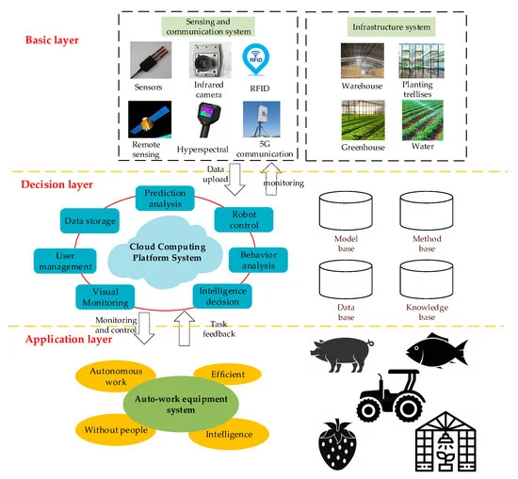

**II. RELATED WORK:**

If climatic condition is hot, dry, sunny, windy then there is need of high amount of water for crops and if these factors are like cold,

humid, cloudy, little wind then we need less water for the crops. Earlier study model conceptualized a system that consist of six parts that are

monitoring, management, planning, Information Distribution, decision support and control action. And above study model does data analysis

for better decision support [1].In [2], a GSM based smart farming system was proposed for doing automation of several farming tasks. Automation is proposed by smartirrigator that moves on mechanical bridge slider arrangement. The smart irrigator receives signal from smart farm sensing system throughGSM module. Then sensed data is transfer towards central database from which all crop details are analysed and transferred to irrigator

system to perform automatic actions.IoT based smart Agriculture [3] gives information about irrigation having facilities like smart control and making intelligent decisiondepending upon real time data from fields. All these operations will be controlled through any smart device placed remotely and theinterfacing sensors are used to perform operations along with Wi-Fi , actuators and other hardware devices.The whole system was developed using infield sensors which collects data from farm and using GPS data is sent to the base station wherenecessary actions are determined to control irrigation according to database available with the system. system. System takes its own decisions and controls the installed

devices and user can control the operations of system using android app or commands in auto and manual mode respectively.Internet of Things is proven to be a cost effective and reliable technology to implement smart systems [5].In smart village system advancerural connectivity is enabled through web service and measuring different environmental factors real time.

System proposed in [6] suggests use of IoT in almost all phases like growing, harvesting, packaging, transportation. Real time dataprovided by sensors, RFID tags in all the above phases of cultivation of crop will help farmers and all the stake holders to have completeview of the product right from the production to sales.Automated farming system proposed in [7] turns on the motor on/off depending on the moisture values from the moisture sensor and turnthe lights in the green house on or off based on the light sensors. Actuators are used to control the motor.Automated system definitely helps farmer in increasing the yield of cropsPaper [8] produces a agricultural model in IoT environment which is human centric. It incorporates IoT and cloud computing ubiquitouslyto remove the inefficiency and lack of management, which are the root of problems in agriculture

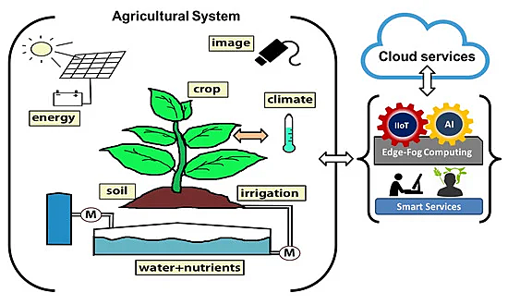

**Flow Diagram:**

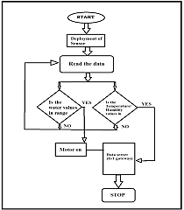

**Benefits of IoT in Agriculture:**

The following are the benefits of IoT in Agriculture:

1.IoT enables easy collection and management of tons of data collected from sensors and with integration of cloud computing services like Agriculture fields maps, cloud storage etc., data can be accessed live from anywhere and everywhere enabling live monitoring and end to end connectivity among all the parties

concerned.

2.With IoT productions costs can be reduced to a remarkable level which will in turn increase profitability and sustainability.

3.With IoT, efficiency level would be increased in terms of usage of Soil, Water, Fertilizers, Pesticides etc.

**SYSTEM DESIGN:**

Architecture of the system consists of hardware – different sensors like temperature, humidity, moisture and Atmega 328microcontroller, battery, RTC module, RF module NRF24L01, and Wi-Fi module.Microcontroller controls all the activities taking place on board. Sensors sense all the physical parameters and convert the analogue valueto digital value. Temperature and humidity sensors are used to measure the temperature and humidity respectively on field. Soil MoistureSensor are of capacitive type, and are used to measure the moisture of the soil.Wind speed is also determined as it affects the amount of water required by crops. RTC module is used for manipulating the real time

data from sensors. This sensed data from the sensors is given to the RF node.

RF nodes are long range nodes as it has an antenna connected to it. For gathering data from various sensor in open farm. These nodes are

ow energy RF nodes equipped with battery. RF nodes transmit the data totheIoT gateway. Data coming on the gateway is further

transmitted to the cloud using Wi-Fi module

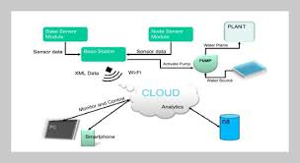

**Screen Shot:**

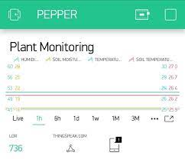

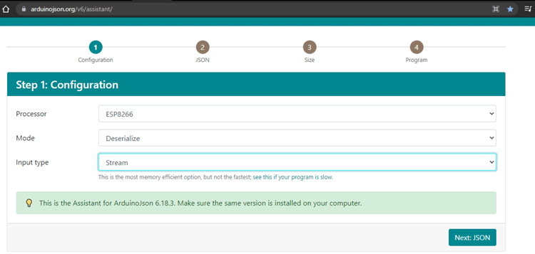

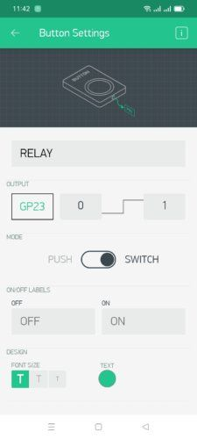

**CONCLUSION:**

IoT based smart farming system can prove to be very helpful for farmers since over as well as less irrigation is not good for farming.Threshold values for climatic conditions like humidity, temperature, moisture can be fixed based on the environmental conditions of thatparticular region. This system generates irrigation schedule based on the sensed real time data from field and data from the weatherrepository. This system can recommend farmer whether or not, is there a need for irrigation.

**FUTURE SCOPE:**

One of the limitations of this system is that continuous internet connectivity is required at user end which might prove to be costly forfarmer. This can be overcome by extending the system to send suggestion via SMS to the farmer directly on his mobile using GSM moduleinstead of mobile app. Weather data from the meteorological department can be used along with the sensed data to predict more informationabout the future which can help farmer plan accordingly and improve his livelihood.

**REFERENCES:**

[**1] Sinung Suakanto, Ventje J. L. Engel, Maclaurin Hutagalung, Dina Angela, “Sensor Networks Data Acquisition and Task**

**Management for Decision Support of Smart Farming” in 2016 International Conference on Information Technology Systems and**

**Innovation (ICITSI) Bandung – Bali, October 24 – 27, 2016**

**[2] Chetan Dwarkani M, Ganesh Ram R, Jagannathan S, R. Priyatharshini “Smart Farming System Using Sensors for Agricultural Task**

**Automation” in 2015 IEEE International Conference on Technological Innovations in ICT for Agriculture and Rural Development**

**(TIAR 2015).**

**[3] Nikesh Gondchwar, Prof. Dr. R.S.Kawitkar, “IOT based Smart Agriculture”, International journal Of Advanced research in**

**computer and Communication Engineering (IJARCCE), Vol. 5, Issue6, June 2016.**

**[4] Narayut Putjaika, Sasimanee Phusae, Anupong Chen-Im, Dr.Phond Phunchongharn and Dr.Khajonpong Akkarajit Sakul, “ A**

**Control System in Intelligent Farming by using Arduino technology”, 2016 Fifth ICT International Student Project**

**Conference(ICT-ISPC).**

**[5] Tejas Bangera , Akshar Chauhan , Harsh Dedhia , Ritesh Godambe , Manoj Mishra, “IOT Based Smart Village”, International**

**Journal of Engineering Trends and Technology (IJETT) – Volume 32 Number 6- February 2016 ISSN: 2231-5381**

**[6] Jeetendra Shenoy, Prof Yogesh Pingle “IoT in Agriculture” 978-9-3805-4421-2/16/ 2016 IEEE**

**[7] Rajalakshmi.P and Mrs.S.Devi Mahalakshmi, “IOT Based Crop-Field Monitoring and Irrigation Automation”**

**[8] Abdullah Na, William Isaac, “Developing a Human-Centric Agricultural Model in the IoT Environment”, 2016 International**

**Conference on Internet of Things and Applications (IOTA) Maharashtra Institute of Technology, Pune, India 22 Jan - 24 Jan, 2016,**

**978-1-5090-0044-9/16 ©2016 IEEE**